

**SMART STAR EXAMINATIONS BOARD**

**END OF TERM ONE EXAMINATION - 2024**

**PRIMARY THREE**

INTEGRATED SCIENCE

***Time allowed : 2*** *hours* ***15*** *minutes*

Pupil's Name **…………………………………………………………………………………………………........................**

School Name**…………………………………………………………………………………………………………...............**

District Name**……………………………………………………………………………………………………….................**

|  |  |  |
| --- | --- | --- |
| **FOR EXAMINERS’ USE ONLY** | | |
| **QN. NO.** | **MARK** | **EXR`S NO.** |
| **1 - 10** |  |  |
| **11 - 20** |  |  |
| **21 - 30** |  |  |
| **31 – 40** |  |  |
| **41 – 43** |  |  |
| **44 – 46** |  |  |
| **47 – 49** |  |  |
| **50 – 52**  **53 - 55** |  |  |
| **TOTAL** |  |  |

**Read the following instructions carefully;**

1. This paper has **two** sections: **A** and **B**.

Section **A** has **40** questions and section **B** has **15** questions.

1. **All** the working for both sections **A** and **B** must be shown in the spaces provided.
2. All working must be done using a **blue** or **black** ball-point pen or fountain pen. Any work done in pencil other than graphs, pictures and diagrams will **not** be marked.
3. Unnecessary **changes** of work and any handwriting that cannot easily be read may lead to **loss of marks.**
4. Do **not** fill anything in the boxes indicated: **“For Examiners’ Use Only”** and boxes inside the question paper.

©*2024 Smart Star Examinations Board*  ***Turn Over***

**SECTION A: 40MARKS**

*Questions* ***1*** *to* ***40*** *carry* ***one mark*** *each*

1. Name **one** animal kept at home.

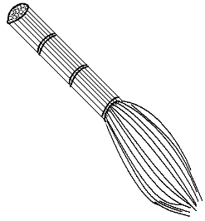_______________________________________________________

1. Name the item below used for cleaning at home.

______________________________________

1. Which component of the environment provides us with heat and light**?**

_______________________________________________________

1. Suggest **one** activity done by farmers in the wet season.

**________________________________________________________**

1. Why do we iron clothes at home**?**

_______________________________________________________

1. Name any **one** element of weather.

**_______________________________________________________**

1. 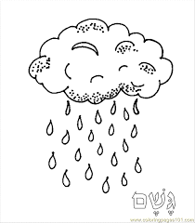Identify the type of weather drawn below.

______________________________________

1. How can we make water safe for drinking**?**

_______________________________________________________

1. Write down any **one** product got from cows.

______________________________________________________

1. How do we call things which have life**?**

______________________________________________________

1. State **one** role of a mother at home.

_______________________________________________________

1. What is a seedling**?**

_______________________________________________________

1. Suggest **one** way of caring for animals at home.

_______________________________________________________

1. How can we prevent malaria at home**?**

_______________________________________________________

1. Why is it bad to play near fire**?**

_______________________________________________________

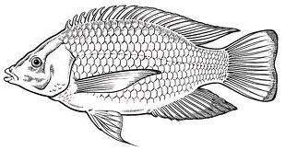Use the diagram below to answer question **16** and **17**.

1. Name the animal above.

______________________________________________________

1. How does the animal above move**?**

______________________________________________________

1. Name **one** place where mothers take their children for immunisation.

______________________________________________________

1. Identify the domestic animal kept to chase away rats.

______________________________________________________

1. Name the item **P.3** pupils use to clean their teeth.

______________________________________________________

**Turn Over**

1. Identify any **one** common disease.

_______________________________________________________

1. What are domestic animals**?**

**_______________________________________________________**

**_______________________________________________________**

1. Mention any **one** item we find in a First Aid box.

_______________________________________________________

1. 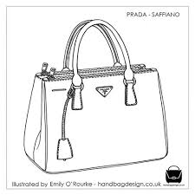 Name the item below made from animal skins and hides

__________________________________________________

1. Which type of soil is good for crop growing**?**

**_______________________________________________________**

1. Give **one** cause of accidents at school.

________________________________________________________

1. What is food**?**

________________________________________________________

1. Name the sense organ used for smelling.

_________________________________________________________

1. Write down any one element of weather.

_________________________________________________________

1. Give **one** reason why we brush regularly.

_________________________________________________________

1. How is the garden tool below important to a farmer**?**

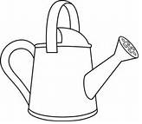

**__________________________________________**

1. Name the type of clouds that bring us rain.

_________________________________________________________

1. Mention **one** cause of soil erosion.

_________________________________________________________

1. Why do people eat food**?**

_________________________________________________________

1. Give **one** health habit a person should do before eating food.

_________________________________________________________

1. Why do we give First Aid to casualties**?**

_________________________________________________________

1. What is the use of spiracles to a housefly**?**

_________________________________________________________

1. Identify **one** animal that lives in soil.

_________________________________________________________

1. Give **one** use of plants to people.

_________________________________________________________

1. Identify **one** way people destroy the environment.

_________________________________________________________

**SECTION B: 60 MARKS**

*Questions* ***41*** *to* ***55*** *carry four marks each*

1. a) Mention **two** components of soil.
2. ________________________________________________
3. ________________________________________________

b) Mention **two** uses of soil to people**.**

**i) ____________________________________________________**

**ii) ____________________________________________________**

**Turn Over**

1. a)Name the parts of the body marked **M** and **N**.

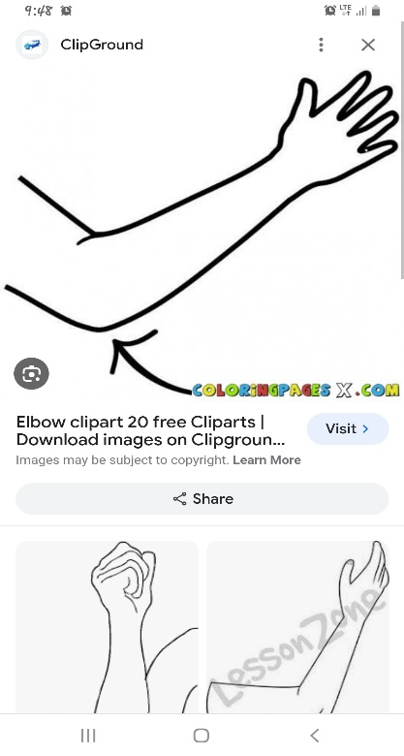

**M**

**N**

**M _________________________**

**N _________________________**

b) State **two** examples of body senses.

i) ________________________________________________

ii)________________________________________________

1. Underline the **natural causes of change** in the environment.

quarrying, earth quakes, storm, cutting trees, hailstorms

brick making, drought

1. 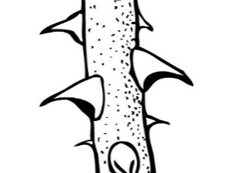a) Name these dangerous objects.

|  |  |  |
| --- | --- | --- |
|  |  | **RAZ** |
|  |  |  |

b) How can people control accidents at home**?**

_____________________________________________________

1. a) What is weather**?**

**_____________________________________________________________**

b) Suggest **two** factors of weather.

i) _____________________________________________________

ii) ____________________________________________________

c) Suggest **one** activity best done in windy weather.

_____________________________________________________

1. a)What is First Aid**?**

______________________________________________________

______________________________________________________

b) Why do we give First Aid to victims**?** Give **two** reasons.

i) ____________________________________________________

ii) ____________________________________________________

c) What do we call a person who has got an accident**?**

______________________________________________________

1. a) Name the parts of a plant.

**C**

**A**

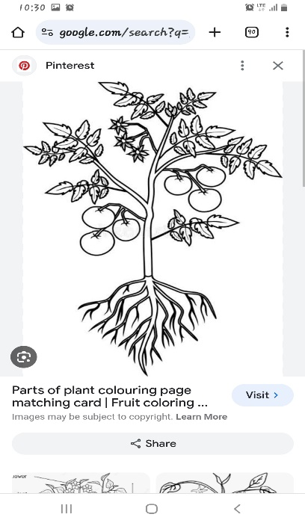

**B**

b) Give **one** use of flowers.

__________________________________________________

1. a) Write down **two** materials for building a permanent house.
2. __________________________________________________
3. __________________________________________________

b) Why do we need houses**?**

**_______________________________________________________**

c) State **one** way of keeping our houses clean.

______________________________________________________

**Turn Over**

The diagram below shows an arrangement of soil layers.

Use it to answer question **49**

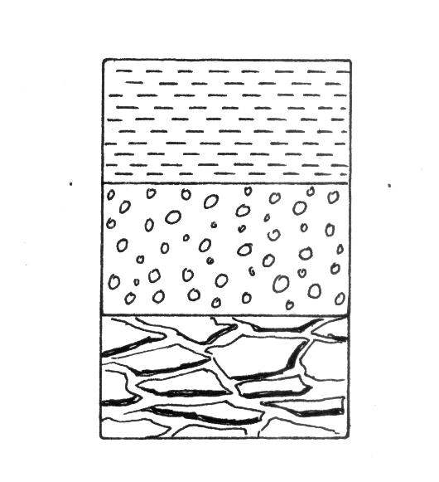

A

C

B

1. a) What do we call the arrangement of soil layers above**?**

_________________________________________________

b) Name the parts **A, B** and **C**

A _____________________________________

B _____________________________________

C _____________________________________

1. a) Name **one** example of insects eaten by man.

______________________________________________________

b) Write **two** products got from bees.

i) ___________________________________________________

ii) ___________________________________________________

c) State **one** way in which insects can be dangerous to people.

_______________________________________________________

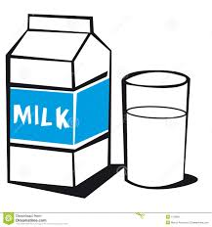

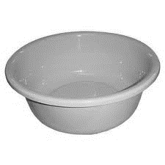

1. How do the following animals **protect** themselves**?**
2. snake _______________________________________
3. cow _______________________________________
4. dog ________________________________________
5. bees _______________________________________
6. a) What are man-made changes**?**

____________________________________________________

1. Give **two** examples of man made changes**?**
   * 1. _______________________________________________
     2. _______________________________________________
2. Name **one** man made thing that can cause changes in the environment.

_________________________________________________

1. Use the diagram below to answer questions that follow.

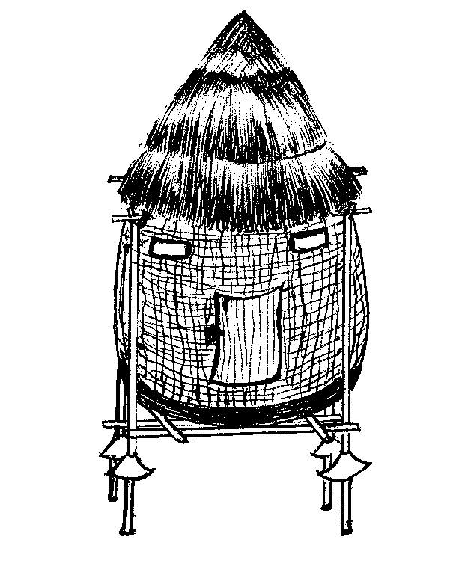

P

a) Name the food storage facility above.

_______________________________________________

b) Name the part marked **P**

**_________________________________________________**

**Turn Over**

c) Identify any **two** food stuffs that can be kept in the above structure.

i) _____________________________________________

ii) _____________________________________________

1. State **one** use of each component of the environment below.

a) lakes ______________________________________

b) forests _____________________________________

c) mountains __________________________________

d) vehicles ___________________________________

1. Match **animals** to their **young ones**.

dog lamb

cat calf

cow kitten

sheep puppy

***HAPPY HOLIDAYS***